

|  |  |
| --- | --- |
| COURSE NAME: | FINANCE & ACCOUNTING WITH ZOHO BOOKS |
| PROJECT TITLE: | DREAM HOME REALTY |
| PROJECT SUBMITTED TO: | SMART INTERNZ |
| YEAR: | 2023-2024 |
| DEPARTMENT: | COMMERCE |
| SEMESTER: | V |
| TEAM ID: | NM2023TMID10405 |
| MEMBERS OF THE GROUP: | |  |  | | --- | --- | | **Register No** | **Student Name** | | 1321151019 | A.Madhumitha (LEADER) | | 1321151018 | V.Lachapriya | | 1321151020 | M.Mahakarthiga | | 1321151021 | K.Mahalakshmi | |
| GUIDED BY: | MRS. M. PRIYANKA M.COM( CA)., M.PHIL. Assistant Professor  MS.S.GOWSALYA M.COM.,M.PHIL., Assistant Professor |
| SPOC NAME: | Ms. K. Elizabeth, M.Sc., M.Phil., B.Ed., Assistant Professor |

**ADVANTAGES OF DREAM HOUSE:**

**Customization:**

* Building a dream house allows you to create a home that is unique tailored to your individual needs and preferences.
* You can choose everything from the layout and design to the home is exactly the way you want it.

**Comfort:**

* A dream house is designed with your comfort in mind, taking into consideration everything from the placement of windows for natural light to the type of healing and cooling systems for optional temperature control.
* This can result in a more comfortable and enjoyable living environment.

**Investment:**

* Building a dream house can be a smart financial investment.
* A well- built and thoughtfully designed home can appreciate in value over time, providing a solid return on investment if you choose to sell in the future.

**Energy efficiency:**

* Building a dream house allows you to incorporate the latest energy-efficient technologies and materials, such as solar panels and energy-efficient appliances, which can save you money on utility bills and reduce your environmental impact.

**Health and safety:**

* A dream house can be designed with health and safety in mind, incorporating features such as non-toxic building materials, air filtration systems and safety features such as smoke detectors and security systems.

**Emotional well-being:**

* These townships provided housing in India for the workers of the industries, with correspondence to the hierarchy of their work, along with other essential facilities such as [schools](https://www.re-thinkingthefuture.com/tag/schools/), markets, recreational spaces, and gathering areas.
* Living in a home that you have designed and built to your specifications can provide a sense of satisfaction and pride.
* Contributing to your emotional well-being and overall quality of life.
* Overall building a dream house can offer a range of benefits from customisation and comfort to financial investment and environmental sustainability, contributing to a happy and fulfilling life.



**Brain storming:** 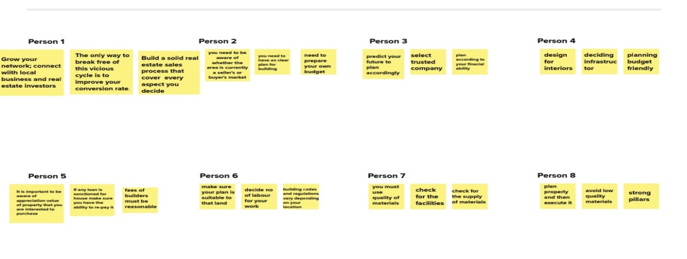

**Empathy map:**

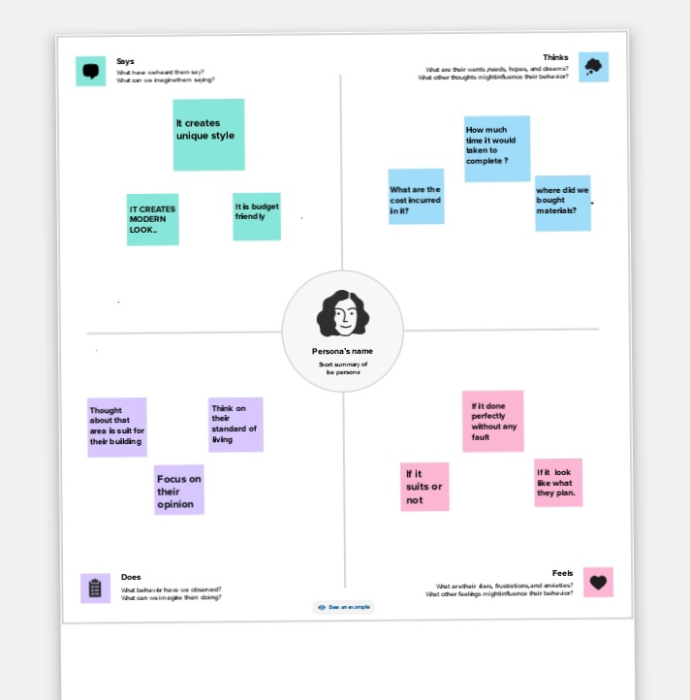

**Problems relating to dream house realty:**

**Real estate agent versus online advertisements:**

* As soon onedecides to buy a house the first immediate questions is if a real estate agent is required or not.
* Many prefer going online and searching for houses for sale as they can avoid brokerage and they can find a plethora of beautiful houses available for every budget.
* One can also play with the filters and refine their search to find a perfect house that suits all their requirements.
* However, there are many who still prefer the conservative way and choose agents to show them houses and are willing to pay a huge brokerage fee.

**Location of the house:**

* One of the main hurdles a home buyer faces is deciding the location of the house.
* There are many advices available online on how to choose the ideal location.
* However, there is no universal rule. Few home buyer prefer picking up an affordable and spacious house on the outskirts of the city than investing a massive amount for a small apartment in a prime location within the city.
* If you are planning to buy a house, you will have to carefully choose a location that will suit your needs.

**Not so honest owners:**

* When buying a house many fear fake owners. there are many house owners who are not honest when they sell their property.
* One of the biggest fears any home buyer will have is if the seller is being honest and giving all the required information. This has also been a concern as owners remain mysterious in most cases.

**Property titles:**

* Most of the properties in our country is in litigation. Every home buyer should check the paperwork and see if the property titles are clear.
* This is a huge challenge as many real estate agents or owners themselves can talk us in to buy the property even though the title is not clear. Many owners claim that the property is jointly owned by a relative who will never cause a problem without getting a consent to sell the house from all the parties involved.
* This often leads to litigation or an expensive settlement. Therefore, getting a property with clear titles is a huge issue.

**Budget and bank loan:**

* To find a perfect house within one’s budget is a challenging task.
* Budget is an important factor that decides the type of the house and the location you can pick.
* There are very few users who can pay the entire pay the entire price of the house in cash.
* Most of the home buyers compromise on the house as they want.
* Most home buyers depends on the home loans to buys a house.
* When the bank fails to offer a good deal, their dream of owning a house is postponed.

**Solutions to the problems in dream house realty:**

**When the local market conditions are not ideal:**

* One problem that seems inevitable within the real estate industry is that you have no control over local market conditions.
* However, you can control how you address this situation with your clients.
* Since local market conditions play a huge role in whether a home sells or not, you need to be aware of whether the area is currently a seller’s or a buyer’s market.
* This set you up with the perfect opportunity to provide valuable advice and information to your clients that will ultimately make urge difference in the outcome.

**When sellers are emotional:**

* Selling home can be an emotional time for many people, and as a real estate agent, get to expenditure it in full force.
* Clients can experience nervousness, uncertainty, excitement, stress, and sadness as well as many other emotions when it’s time to move on.
* This can create a challenge for both you and the homeowner.
* To overcome this roadblock, be prepared to handle these common emotions. Have an abundance of benefits to selling a home on hand to sahre and be understanding of your client’s needs.
* Always keep your own personal emotions out of it, as well.

**When we disagree Over Pricing the Home:**

* As A Real Estate Agent, You Will Come Across Clients That Will Take You Recommended Listing Price And Tun With It, And Others That Think Their Home Is Worth More Than It Truthfully Is.
* Pricing A Home Is One Of The Biggest Challenges, Especially If You Have A Client That Is Adament On A Specific Asking Price.
* Educate Your Clients On The Devasting Consequences That Van Follow An Overpriced Home And The Reason For Your Number.
* Provide Statistics And Facts To Display Your Concrete Evidence And Ensure The Home Will Not Sit Market For Months Without An Offer.

**When Home Buyers Are Unrealistic:**

* On the contrary, you will also come across the clients that are unrealistic home buyers. They want it all for nothing.
* They want to go in with a significantly lower price than what the home is worth.
* Unrealistic home buyers may also have unreasonable opinions about the condition of a home.
* To overcome this common problem that any real estate agents experience, you need to have an understanding of the home’s conditions, the conditions of the current economy, sellers, and overall market.
* A direct and affirmative approach to addressing a client’s concerns should be backed up with facts, statistics and numbers in order to allow them to completely trust your decisions.

**Should we rent or buy:**

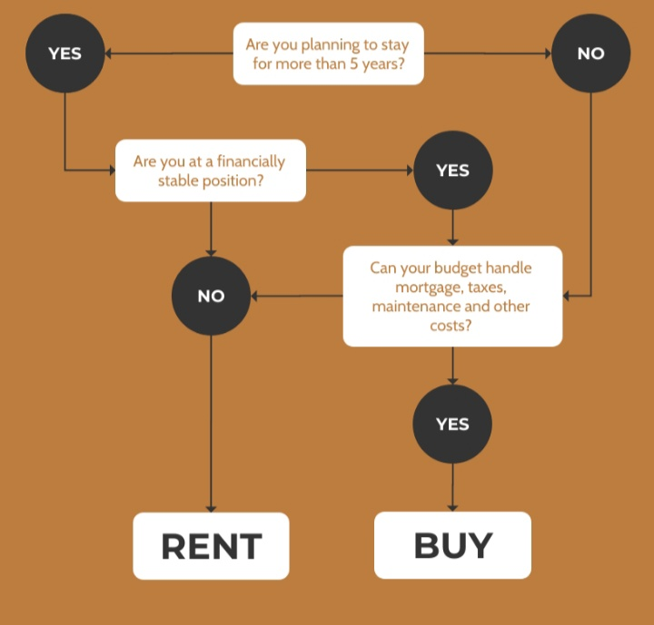

**Project flow:**

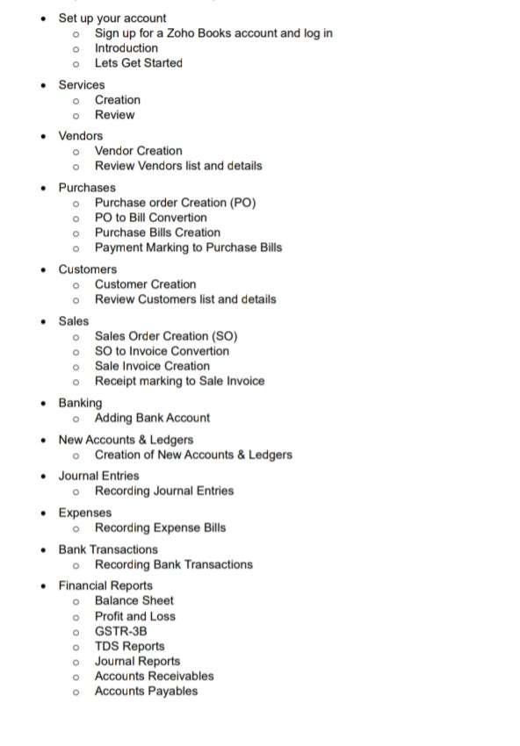

**Conclusion:**

* Buying a house is not a decision one makes frequently. It is a once in a life time decisions. It requires a lot of planning, searching and networking.
* These are only a few problems that home buyers face when they are planning on buying a house.
* There are many other issues like the appreciation costing the area, bad credit score and false promises by builders/developers.
* Hope you find the right house.